Parameter Testing 4: Eval Runs & Random Seed: Eval=4, seed disabled (stability test)
This experiment will have every setting set to the default with the only differences being maxing out the eval runs per candidate (the max being 4) and disabling the random seed and using the default seed (the default seed being 42). This approach seeks to test the stability of the runs and evolution by seeing how it makes a difference with those settings.
Parameter Settings
Parameter | Value
Problem Type | Pacman
Gemini Model | gemini-2.0-flash
Input Type | Python
Initial Code | Default Pacman agent
Generations | 5
Population Size | 4
Top-k | 1
w1 / w2 / w3 | 0.5 / 0.3 / 0.2
Fix Random Seed | Seed disabled
Eval Runs | 4
Human-in-Loop | (empty)
Tester | Kevin Sanchezz

Run
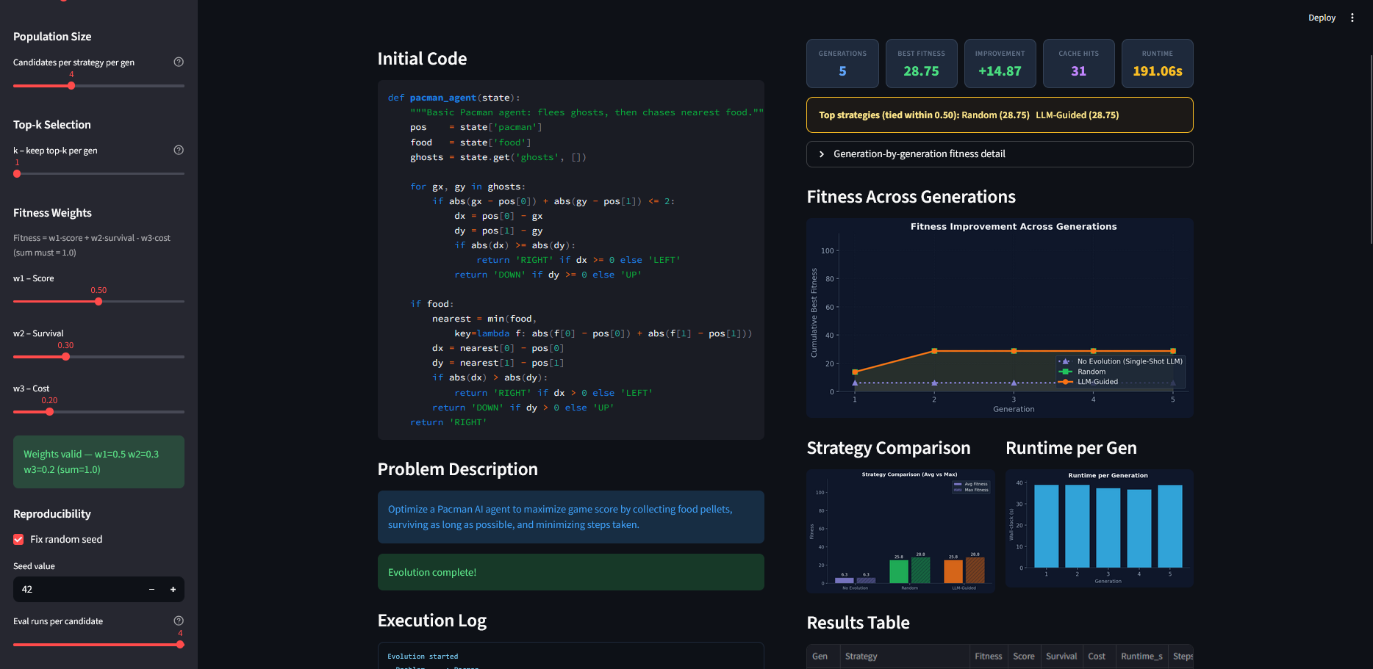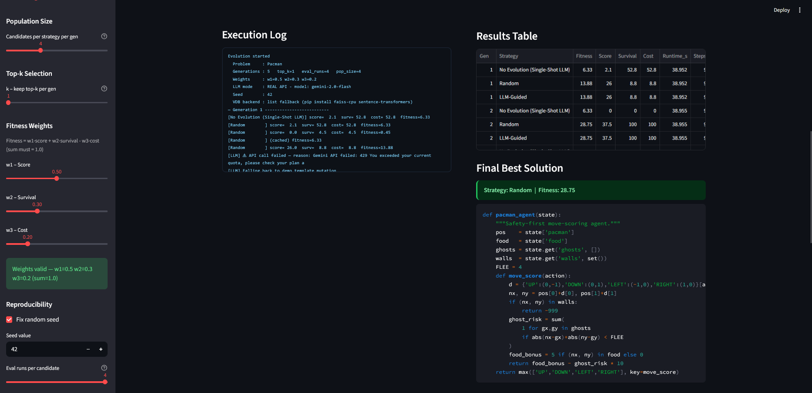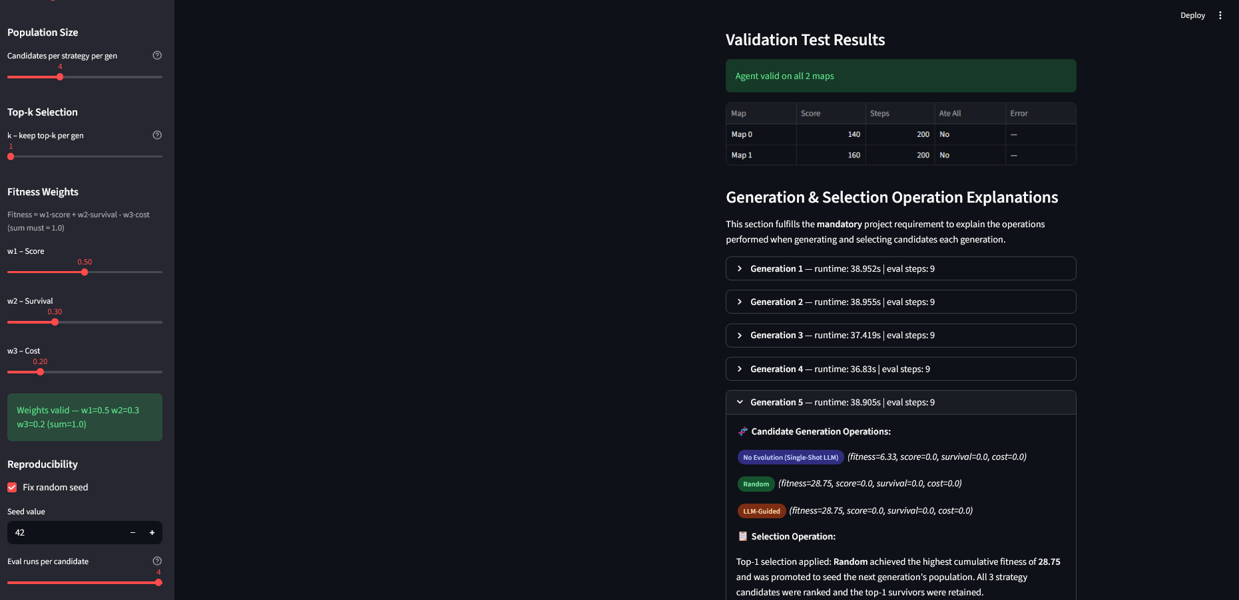
Fitness Performance
The run produced a best fitness score of 28.75 and a +14.87 improvement over the baseline starting code demonstrates that the evolutionary process was able to achieve at an early stage of its evolution, flattening out the fitness graph at around its second evolution. That being compared to the default run with a best fitness score of 28.5 and an improvement of +20.25. Both have the same best fitness score but a noticeable difference in improvement.
Fitness Trajectory Across Generations
The fitness chart shows an upward trend, specifically for the Random and LLM-Guided techniques. Both of those techniques had grown between the first and second generation with the graph being flattened out during the rest of the test. This is similar to the basic run but at an earlier generation instead. In a standard run with no modifications other than the default, it took till generation 3 to flatten out the graph curve.
Strategy Comparison
In this run, Random and LLM-Guided strategies tied at 28.75, with No Evolution (Single-Shot LLM) not showing much if any growth at all after the first generation while a default run pushed it back a generation. This could be because of the fact that there are more evals that each generation is able to do which results in more testing in each generation which results in more growth early on in the run.
Cache Hits
The run generated 31 cache hits compared to a basic run of 33 hits. With the only key difference being the amount of evals, this could be caused by just the fact that it learns slightly faster than a normal run.
Runtime Efficiency
The test run took around 191.81 seconds, compared to the default run of 186 seconds. Both of these runs have a near identical runtime. The most likely reason for this is because both runs learned early on how to complete the course well enough to where the following generations were able to complete their runs with ease. But the slightly longer time caused by the test run would likely be caused by the number of evals being increased which makes the first generation work itself harder so those who come after can have an easier time.
Key Takeaways for the Report
- The greater the evals, the more likely the earlier generations can master the course
- Once early on the course has been mastered, the later generations have an easier time
- With no random seed, the generations have an easier time learning since there is no need to adapt
- The runs got labeled as a top strategy

